

**Sultan Qaboos University**

**College of Science**

**Department of Computer Science**

**COMP3700: Introduction to Web Computing**

**Fall 2022**

**Project- 3:**

Javascript and Dyanmic HTML

SUNSET hotel

|  |  |  |
| --- | --- | --- |
| **Name:** |  | **ID:** |
| Ya’Rab Mohammed Al Mamri |  | 130376 |
| Qusai Al-Toobi |  | 131791 |
| Ali Hamad Al-Harrasi |  | 131495 |
|  |  |  |

Table of Contents

Part1 3

Part2 8

Part3 ……………………………………………………………………………………………………………………………………………… 10

Part4 ……………………………………………………………………………………………………………………………………………… 12

Part5 …………………………………………………………………………………………………………………………………………… 16

Contributions ……………………………………………………………………………………………………………………………… 18

## 1.

Part1

**First page:**

The code for the checking page (that checked if the vip room empty or not)

  <script>

        var cols = ['name', 'Floor', 'Room']

        var data = [{

            id: 0,

            name: "Room1",

            Floor: "Floor1",

            Number:001,

            isEmpty: true

        }, {

            id: 1,

            name: "Room2",

            Floor: "Floor2",

            Number:002,

            isEmpty: false

        },{

            id: 3,

            name: "Room3",

            Floor: "Floor3",

            Number:003,

            isEmpty: false

        }, {

            id: 4,

            name: "Room4",

            Floor: "Floor4",

            Number:004,

            isEmpty: false

        }]

        // Create Table and Header

        var t = document.createElement('table');

        t.classList.add('scooby-gang', 'listing');

        t.appendChild(document.createElement('thead'));

        t.querySelector('thead').appendChild(document.createElement('tr'));

        for (var i = 0; i < cols.length; i++) {

            var heading = document.createElement('td');

            heading.textContent = cols[i];

            t.querySelector('thead tr').appendChild(heading);

        }

        document.getElementById('wrapper').appendChild(t);

        // Create rows

        for (var i = 0; i < data.length; i++) {

            var s = data[i];

            var r = document.createElement('tr');

            r.dataset.personId = s.id;

            r.id = s.name.toLowerCase() + "-row";

            var nameCell = document.createElement('td');

            nameCell.textContent = s.name;

            nameCell.classList.add('name');

            nameCell.dataset.personId = s.id;

            var FloorCell = document.createElement('td');

            FloorCell.textContent = s.Floor;

            FloorCell.classList.add('Floor');

            FloorCell.dataset.personId = s.id;

            var NumberCell = document.createElement('td');

            NumberCell.textContent = s.Number;

            NumberCell.classList.add('Number');

            NumberCell.dataset.personId = s.id;

            r.appendChild(nameCell);

            r.appendChild(FloorCell);

            r.appendChild(NumberCell);

            t.appendChild(r);

        }

        function getScoobyNameById(pid) {

            for (var i = 0; i < data.length; i++) {

                if (data[i].id === Number(pid)) {

                    return data[i].name;

                }

            }

            return null;

        }

        function isScoobyDemon(pid) {

            for (var i = 0; i < data.length; i++) {

                if (data[i].id === Number(pid)) {

                    if (data[i].isDemon) {

                        return data[i].name + " is a Empty."

                    } else {

                        return data[i].name + " is not a Empty."

                    }

                }

            }

            return null;

        }

        function logInfo(actionNum, pid) {

            console.log(

                "Action " + actionNum + " Player: " + getScoobyNameById(pid) +

                " and " + isScoobyDemon(pid)

            );

        }

        function action1(e) {

            alert(

                "Action One Current Target: " + e.currentTarget.tagName +

                "\nTarget: " + e.target.tagName

            );

            if (e.currentTarget.tagName === 'TR') {

                console.log("THIS ONE IS A TR");

            }

            logInfo(1, e.target.dataset.personId);

        }

        function action2(e) {

            alert(

                "Action Two Current Target: " + e.currentTarget.tagName +

                "\nTarget: " + e.target.tagName

            );

            logInfo(2, e.target.dataset.personId);

        }

        function action3(e) {

            alert(

                "Action Three Current Target: " + e.currentTarget.tagName +

                "\nTarget: " + e.target.tagName

            );

            logInfo(3, e.target.dataset.personId);

        }

        function action4(e) {

            alert(

                "Action Four Current Target: " + e.currentTarget.tagName +

                "\nTarget: " + e.target.tagName

            );

            logInfo(4, e.target.dataset.personId);

        }

        var cells = document.querySelectorAll("td.name");

        // Assign action 1 handler to name cells

        for (var i = 0; i < cells.length; i++) {

            cells[i].addEventListener('click', action1);

        }

        // Assign action 2 handler to third row by element id

        document.querySelector("#" + data[2].name.toLowerCase() + "-row").addEventListener('click', action2);

        // Assign action 3 handler to table

        document.querySelector("#wrapper table").addEventListener('click', action3);

        // Assign action 4 handler to div that wraps table

        document.querySelector("#wrapper").addEventListener('click', action4);

    </script>

The website will show the rooms and the (Floor , no Room) , if the costumer click on it will inform him by alert if the room empty or not

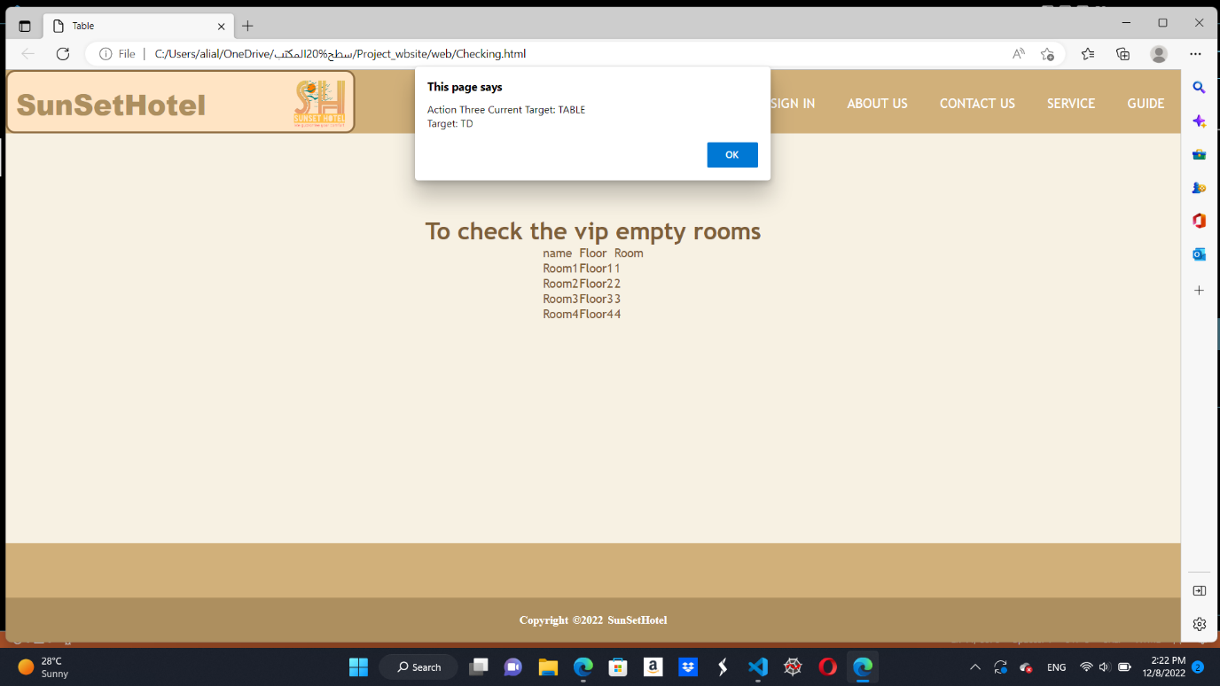

**Second page:**

This Script will give information about what the customer checked or unchecked

<!--this script checking whatever the checkbox checked or not-->

<script type="text/javascript">

var checkboxes = document.querySelectorAll(".checkbox");

// this loop used to check if the checkbox checked or not

for (var checkbox of checkboxes) {

  checkbox.addEventListener("click", function () {

    if (this.checked == true) {

        console.log(this.value)

    } else {

     console.log("you checked the checkbox")

    }

  })

}

If the costumer checked any box immediately will appear in the system

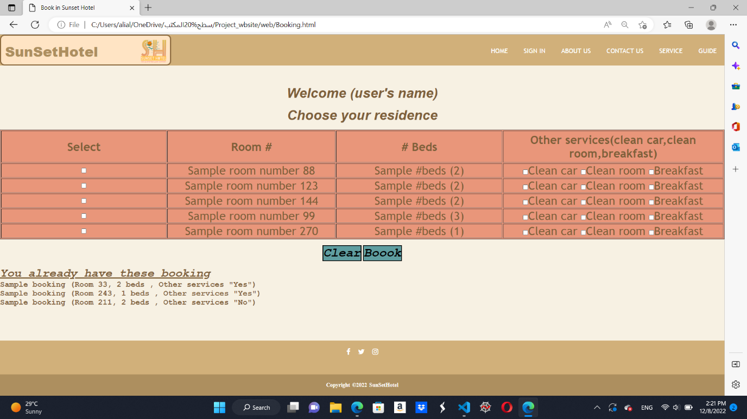

## 2.

Part2

The Questionnaire page , it is a page that gives a feedback about the services of the Hotel

          <!--Script to know the pepole experience-->

      <script type="text/javascript">

          function check(){

      var question1 = document.quiz.question1.value;

      var question2 = document.quiz.question2.value;

      var question3 = document.quiz.question3.value;

      var question4 = document.quiz.question4.value;

      var correct = 0;

      // the correct or the best services we have

      if (question1 == "Great") {

          correct++;

      }

      if (question2 == "5-10") {

          correct++;

      }

      if (question3 == "car wash") {

          correct++;

      }

      if (question4 == "Pool") {

          correct++;

      }

      var messages = ["Great", "We hope you can enjoy next time", "We will consider your feedback as number one of our priorty to improve"];

      var score;

      // check the rate

      if (correct == 0) {

          score = 2;

      }

      if (correct > 0 && correct < 3) {

          score = 1;

      }

      if (correct == 3) {

          score = 0;

      }

      document.getElementById("after_submit").style.visibility = "visible";

      document.getElementById("message").innerHTML = messages[score];

      }

      </script>

For Example we have servies that we want to imporve , if he/she chooce the bad facilties and rate us very law , this will help the hotel to imporve an many ways.

First Example:

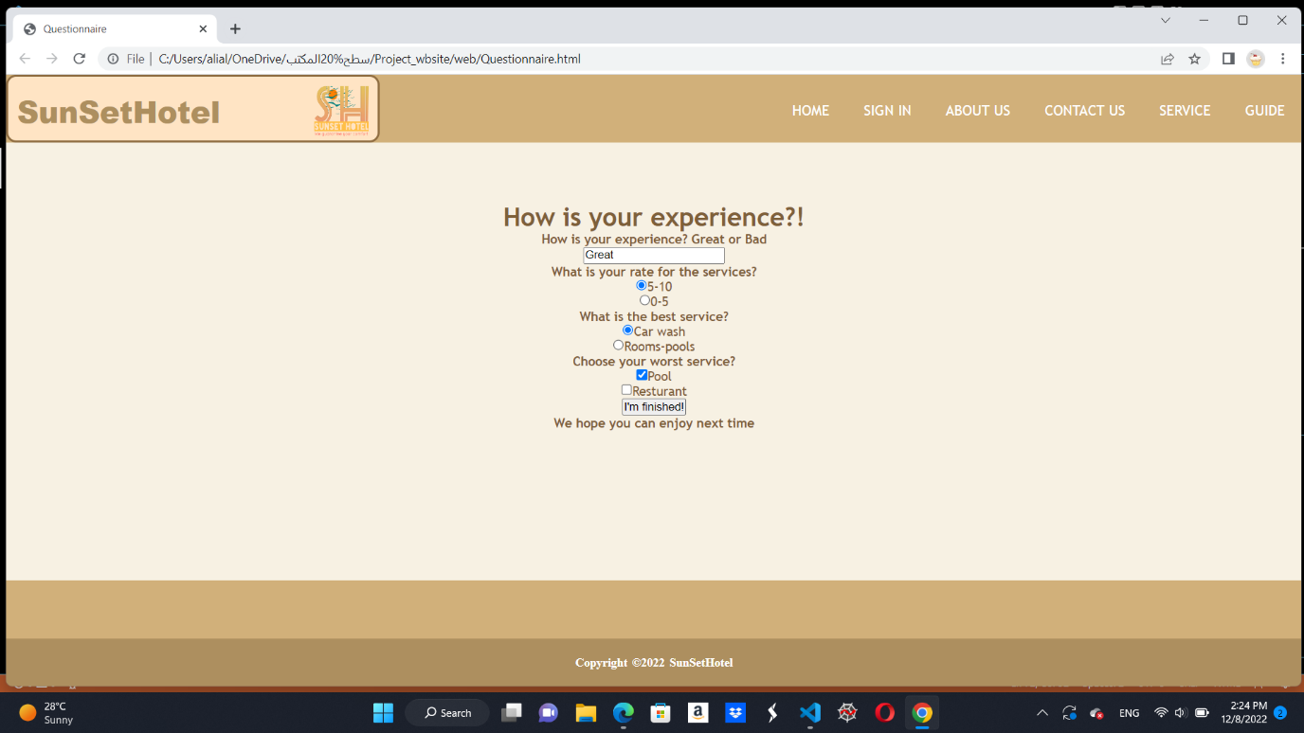

Second Exampl:

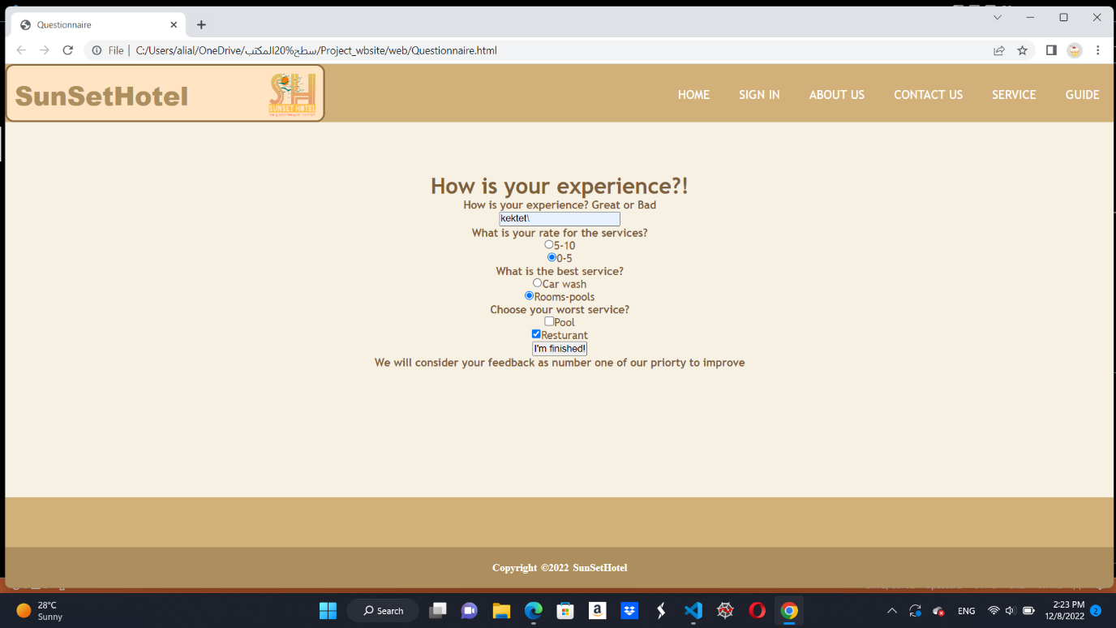

**Part3**

**calculate** **page:**

**JavaScript** **code** to display bill to the user.

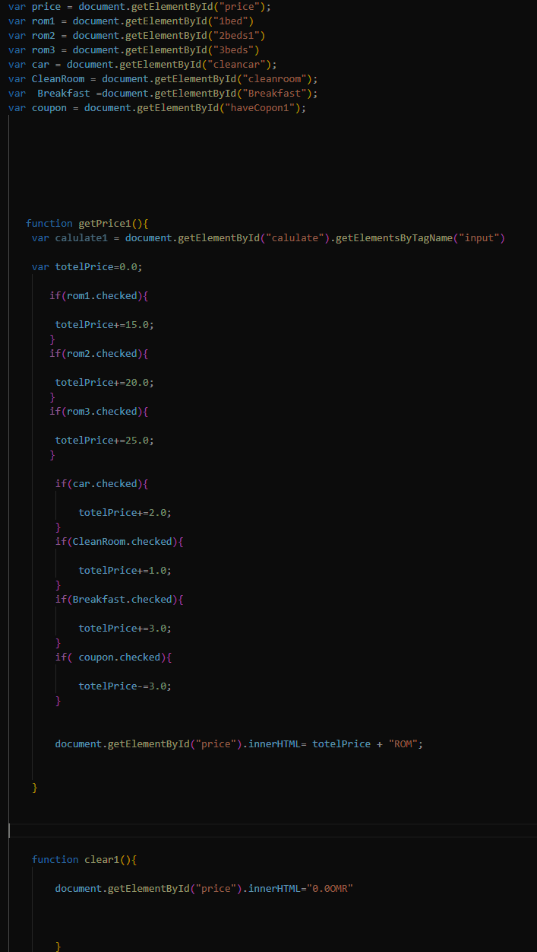

The tenant can choose 1,2 or 3 beds. Also, there are 3 services clean car, clean room, and breakfast. if the tenant has a coupon will get a discount 3 ROM.

Exampl1: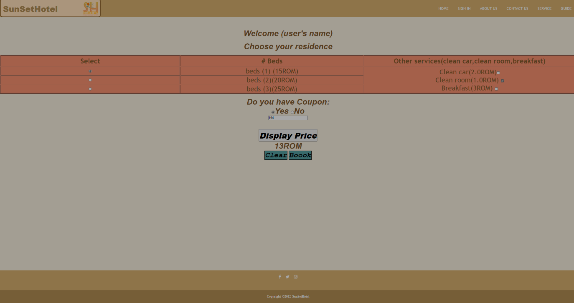

Exampl2:

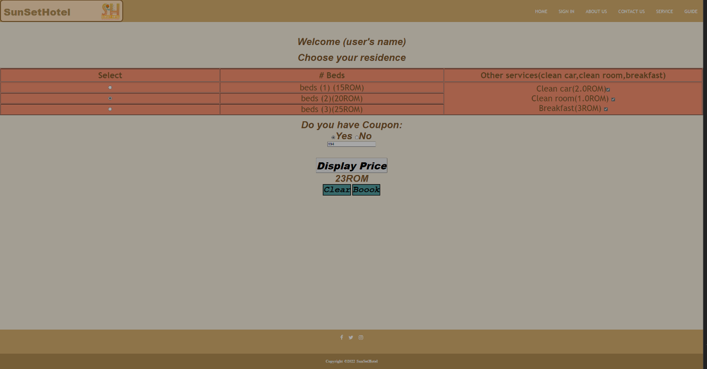

**Part4**

**Fun page**:

**JavaScript** code that applied in funpage.html to display the game (X/O game)

The code run the game from the beginning tell one of three situations (player X wen, player O win, no winner).

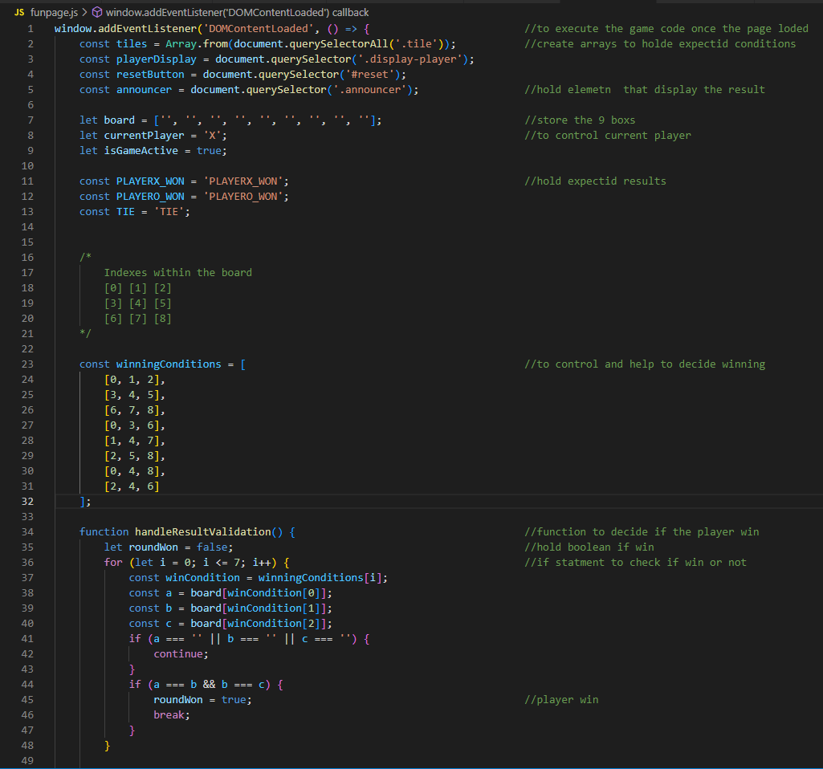

**The web page(funpage.html):**

-clean board:

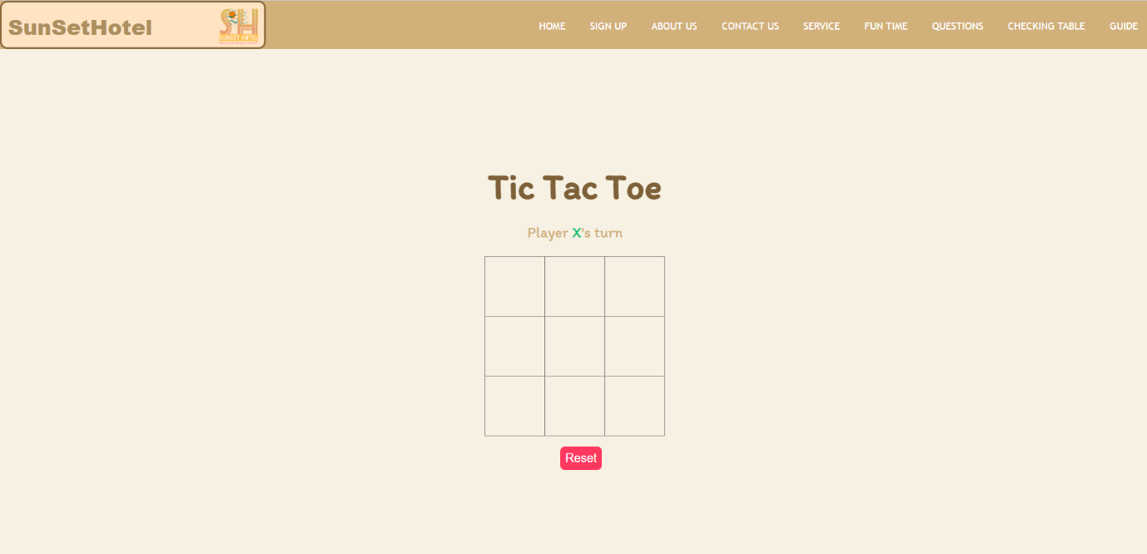

Situation 1(player X win):

Situation 2(player O win):

Situation 3(no winner):

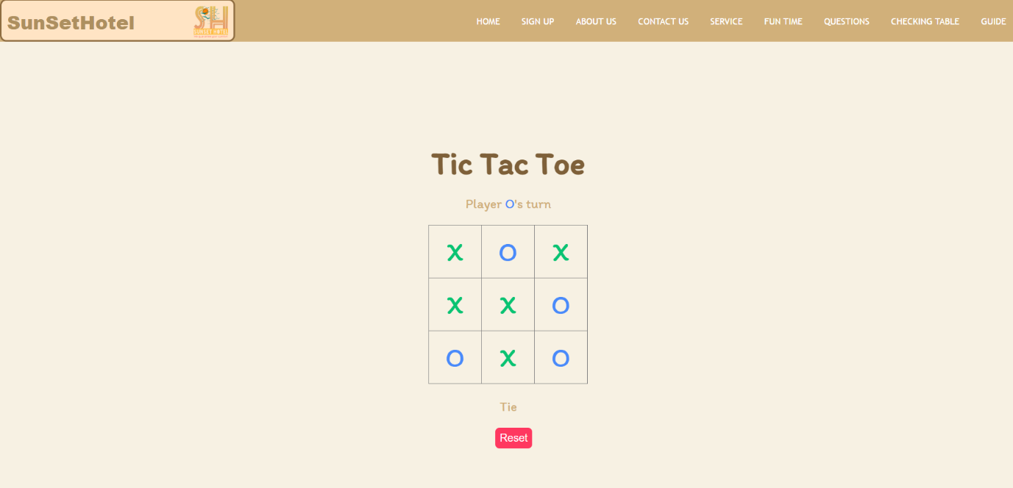

**Part 5:**

**JavaScript:**

1. JavaScript for display a text banner that have date and time and moving with CSS help.

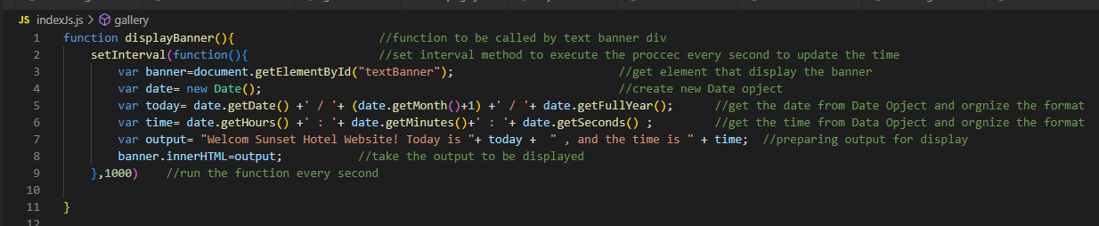

1. JavaScript code to display a set of images and switch between them.

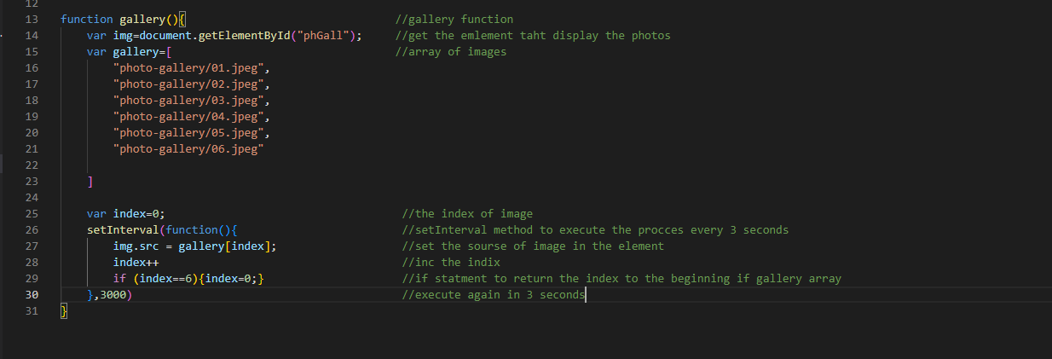

**Index.html:**

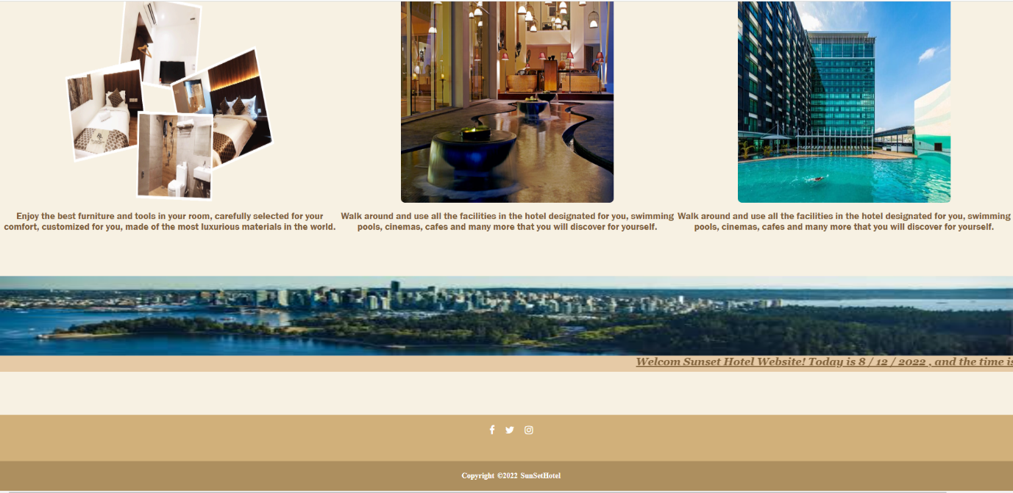

After 3 seconds:

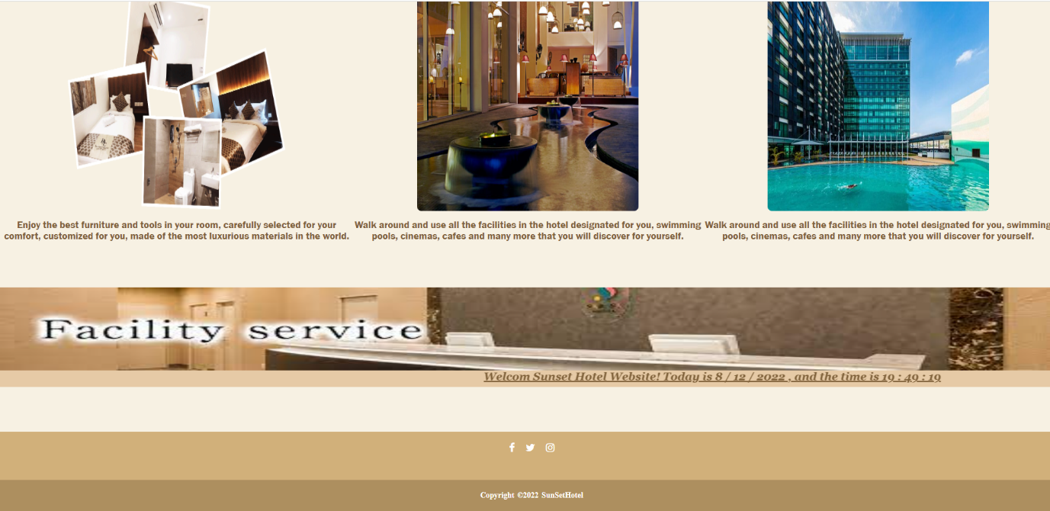

After another 3 seconds:

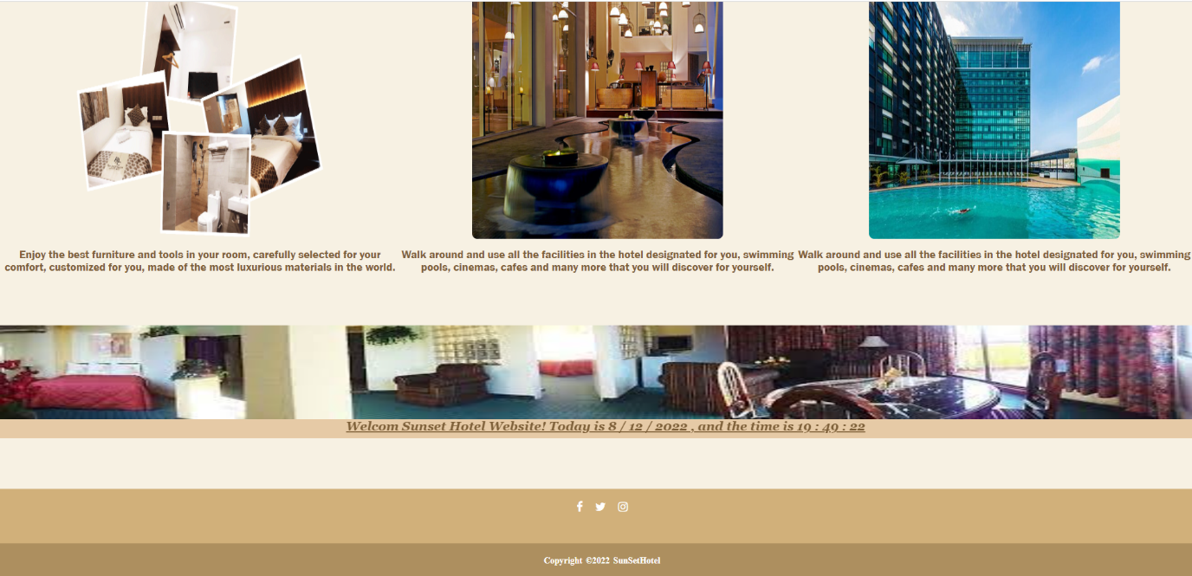

**Contributions:**

|  |  |  |  |  |  |
| --- | --- | --- | --- | --- | --- |
|  | Part 1 | Part 2 | Part 3 | Part 4 | Part 5 |
| Ya’Rab Mohammed Al Mamri | **0%** | **10%** | **20%** | **65%** | **70%** |
| Qusai Al-Toobi | **30%** | **25%** | **65%** | **15%** | **10%** |
| Ali Hamad Al-Harrasi | **70%** | **65%** | **15%** | **20%** | **20%** |